Electromagnetic Field

The general field consisting of superimposed electric and magnetic fields is called an electromagnetic field. While properties such as the potential energy stored in the field remain invariant of the observing reference frame, special relativity shows that different observers will actually see differing strength of the constituent electric and magnetic fields. The electric and magnetic components of an electromagnetic field are untitled in special relativity into an entity known as the electromagnetic field tensor.
The potential energy of an electromagnetic field consisting of an electric field E and a magnetic field B in cgs is
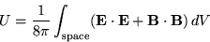 | (1)

and in MKS,
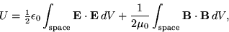 | (2)

where is the permittivity of free space and is the permeability of free space.
For a particle in an electromagnetic field, the motion is circular.
(3)

(4)

Let in (4)
(5)

and differentiate both sides
(6)

Plugging in (3) now gives
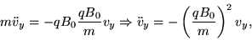 | (7)

so the solution is
(8)

where
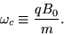 | (9)

Integrating gives
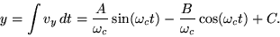 | (10)

We can now apply the initial conditions
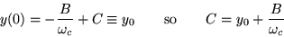 | (11)

(12)

so (10) becomes
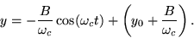 | (13)

Similarly, let in (3)
(14)

and differentiate both sides
(15)

Plugging in (4) now gives
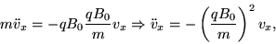 | (16)

so the solution is
(17)

Integrating gives
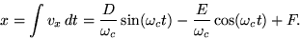 | (18)

We can now apply the initial conditions
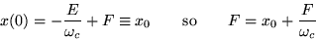 | (19)

(20)

so (18) becomes
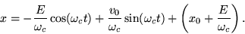 | (21)

However, (18) and (21) must also satisfy (3)
(22)

so
(23)

Therefore E = 0 and
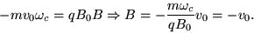 | (24)

Plugging these in to (13) and (21) give
 |  | 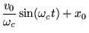 | (25)
 |  | 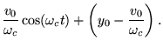 | (26)
But manipulating (25) and (26) gives
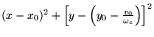
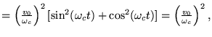 | (27)
so the particle travels in a circle centered at with radius .
If the electric and magnetic fields are at right angles, the path is a cycloid (Jeffreys and Jeffreys 1988).
Electric Field, Electromagnetic Field Tensor, Magnetic Field

